THE UNIVERSITY of TENNESSEE

DEPARTMENT of INDUSTRIAL and
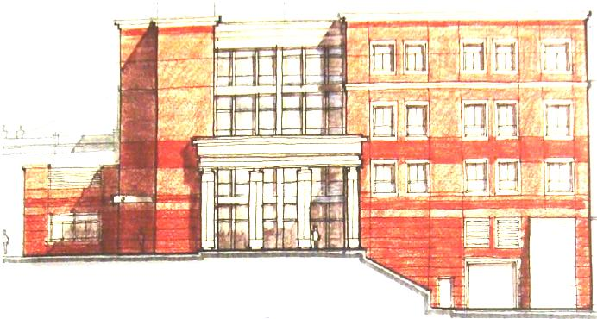
SYSTEMS ENGINEERING
College of Engineering

GRADUATE HANDBOOK

FORMS

M.S. and Ph.D. in Industrial Engineering and
Concentration on Engineering Management
M.S. in Reliability and Maintainability Engineering

The University of Tennessee
Department of Industrial and Systems Engineering
DEGREE PLAN
Student’s Name: _________________________ Student ID: ____________
Date of Submission: ___________________________
COURSES | COURSE TITLES | CREDIT HOURS | GRADES
 | Total Number of Credit Hours
Chair: _____________________________ Department _______
Member: _____________________________ Department _______
Member: _____________________________ Department _______
Member: _____________________________ Department _______
*For the students enrolled in PhD program, include courses from MS degree approved to be counted as part of the minimum total of 72 credits.
COMPREHENSIVE EXAM CHECKLIST
The student is responsible for completing this checklist before the comprehensive exam is scheduled. This checklist must accompany the Report of Comprehensive Exam form. The student should initial each appropriate blank indicating that the specified criterion has been satisfied, or where appropriate, been waived.

Student Name _____________________________ Student ID: _____________
Please check compliance with each requirement.
- Registered for semester term during which the exam occurs. (If the entire exam is between semesters, then the student must have been registered for the preceding term). ____

- Student has a degree plan approved by the committee. ____

- GPR over all eligible courses since beginning graduate work at UT is greater than or equal to 3.000 (Includes 300 and 400 level courses taken while in a graduate program but does not include transfer courses.) ____

- GPR over all courses on the degree plan (excluding transfer courses) is greater than or equal to 3.000 as indicated in the degree evaluation.) ____

- All committee members have scheduled or waived the written portion and agreed to attend the oral portion of the exam or found a substitute. Only one substitute is allowed; there may not be a substitute for the chair. ____

- At the end of the semester in which the exam is given, there are no more than 6 hours of course work remaining on degree plan. (Does not include IE 600s). ____

- Comprehensive examinations must be taken within five years from the time of a student’s first enrollment in a doctoral degree program. ____

Student Signature _____________________________
Date __________________________

The University of Tennessee
Department of Industrial and Systems Engineering
REPORT OF COMPREHENSIVE EXAM
Student’s Name: _________________________ Student ID: _____________

The Written Portion of the Exam must be considered satisfactory by all committee members. The Oral Exam is taken only when all written components are satisfactory.

Are All Written Components Satisfactory? Yes ______ No________
We have examined the student over the material covered by courses listed in the degree plan. After the examination the number of votes casted by the committee members are as follows:

Members Voting Yes ____
Members Voting No ____

Approval Recommended:
Chair: _____________________________ Department _______
Member: _____________________________ Department _______
Member: _____________________________ Department _______
Member: _____________________________ Department _______

Date of Oral Examination ________________

The University of Tennessee
Department of Industrial and Systems Engineering
PROPOSAL APPROVAL RECORD

Student’s Name: _________________________ Student ID: _____________
Date of Examination: ________
Note: The proposal should be approved no later than one semester after the comprehensive examination has been passed.
The comprehensive (oral) exam was passed on _________________

TENTATIVE TITLE OF PROPOSAL FOR PhD DISSERTATION

RECCOMENDATIONS BASED ON EXAM

APPROVAL RECOMMENDED

Chair: _____________________________ Department _______

Member: _____________________________ Department _______

Member: _____________________________ Department _______

Member: _____________________________ Department _______

Date of Approval ________________

